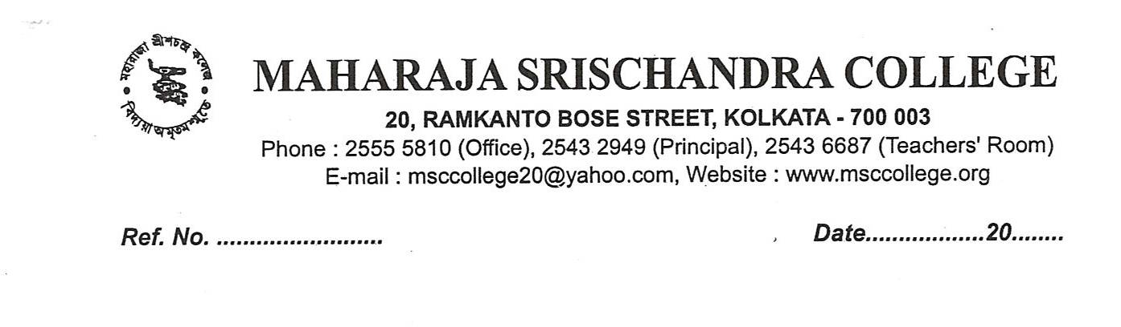
NOTICE
Inviting fresh application through e mail from candidates from 05.09.2019 to 10.09.2019 for the following subjects. The merit List will be published on 11.09.2019 (after 7.00 PM). Format for fresh application will be available at the end of this notice. [Please fill the form and send it back to e-mail address msccadmission@gmail.com by attaching it along with the scanned copy of mark sheet]
Sl  No | Subject | Who can apply | Minimum Criteria (Aggregate is based on the best 4 subjects)
1 | Bengali (Hons) | All Candidates | Minimum University Norms
2 | English (Hons) | SC/ST/OBC-A Candidates Only | 60% in Aggregate and 60% in Subject OR 55% in Aggregate and 70% in Subject
3 | Hindi (Hons) | SC/ST/OBC-A /OBC-B Candidates Only | Minimum University Norms
4 | Political Science (Hons) | All Candidates | Minimum University Norms
5 | History (Hons) | All Candidates | Minimum University Norms
6 | Economics (Hons) | All Candidates | Minimum University Norms
7 | B.Sc. (Gen) | All Candidates | Pass marks in HS or Equivalent Examination  (i) If anyone chooses mathematics as a paper he/ she should have to secured pass marks in mathematics.  (ii) (a) Students with Economics in plus 2 level has to secured pass marks in economics and mathematics.  (b) Students without Economics in plus 2 level has to secured pass marks mathematics.  (iii) If anyone chooses Geography he/she should secured 55% in Geography

APPLICATION FORM FOR ADMISSION
1. Name of the candidate:
2. Father’s name :
3. Date of birth :
4. Gender :
5. Caste/ Category :
6. Contact Mobile No :
7. Email address :
8. Address :

9. Particulars of Last Examination
(a) Name of the Examination :
(b) Name of the board :
(c) Year of Passing :
(d) Roll No :
(e) Marks obtained in the last HS or equivalent examination
Subject |  |  |  |  |  |  | Percentage
Full Marks
Marks obtained

10. Subject applied for :
(Before applying please read the criteria available in the admission section of college website)
Hons Subject  (if any) | Generic/General Subject |  |  | AECC 1  (Beng/ Eng/ Hindi)

